**Introduction:**

Jeronimo wants to open his Burger Joint in some Locality (District) of Bogotá, Colombia and he is asking our help in finding the best Locality.

**Business Problem:**

In order to open Jeronimo's burger joint, we will have the need to use some information about the Localities in Bogotá. We must be sure that the place where the burger joint is opened will have enough customers and also that there aren't a large amount of burger joints in the place.

**Data:**

To help Jeronimo in his search we will need to access following data:

1. The Localities of Bogotá, Colombia from Wikipedia: <https://es.wikipedia.org/wiki/Anexo:Localidades_de_Bogot%C3%A1>
2. The coordinates (latitude, longitude) of these Localities of Bogotá from Open Street Map APIs
3. From Foursquare we will need following venues data:

* The burger joint venues of the Localities
* The offices venues of the Localities
* The high schools’ venues of the Localities
* The universities venues of the Localities

We will then leverage the data in order to determine which locality is the most appropriate in order to locate the burger joint.

**Methodology:**

* For each locality, all office, school, university and burger joints venues data have been collected from Foursquare.
* Then for each locality, the sums of the office, school, university and burger joints were computed.
* For each of these four categories, a weight (or penalty) has been defined according to what Jeronimo considers the most important.
* Burger Joints have been weighted with -1, since Paolo wants to avoid concurrence.
* Schools have been weighted with 1, since student are good customers.
* Universities have been weighted with 1.5, since students are good customers.
* Offices have been weighted with 2, since employees are even better customers.

**Note**: The weights can be modified according to the importance of each category. A score was computed for each locality as the weighted sum of the number of venues in each of the 4 categories (school, university, office, burger joints).

*Localities of Bogotá, Colombia*

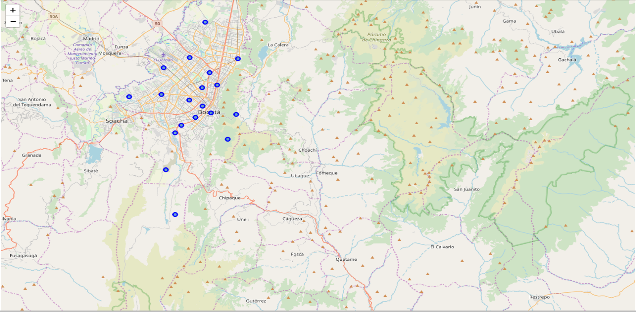

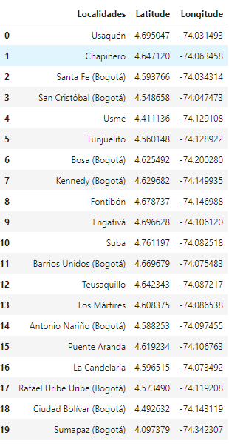

*Burger Joints in Bogotá Localities*

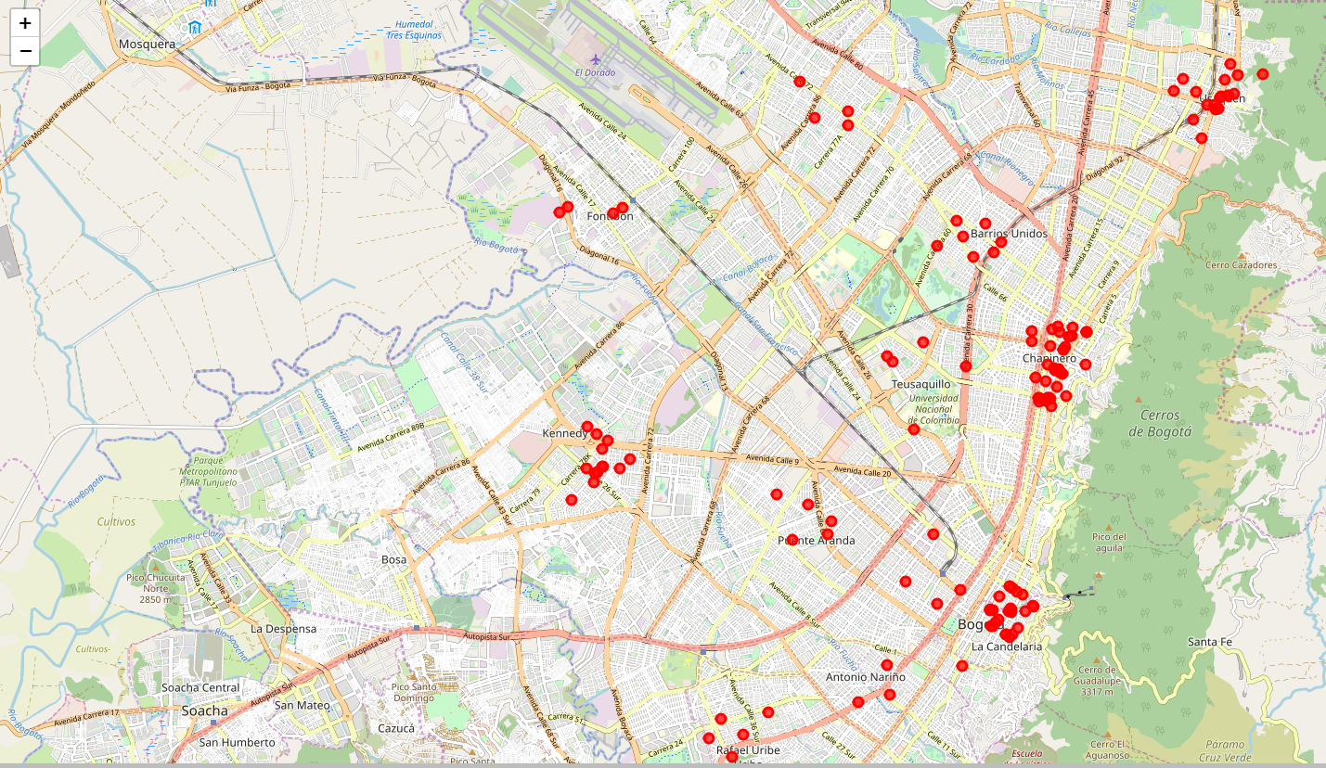

*High School in Bogotá Localities*

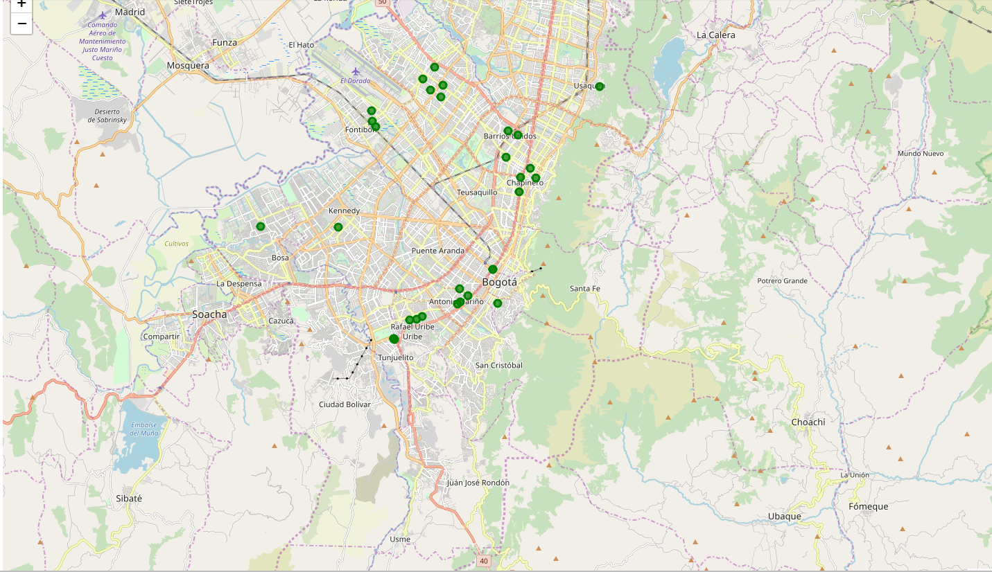

*Universities in Bogotá Localities*

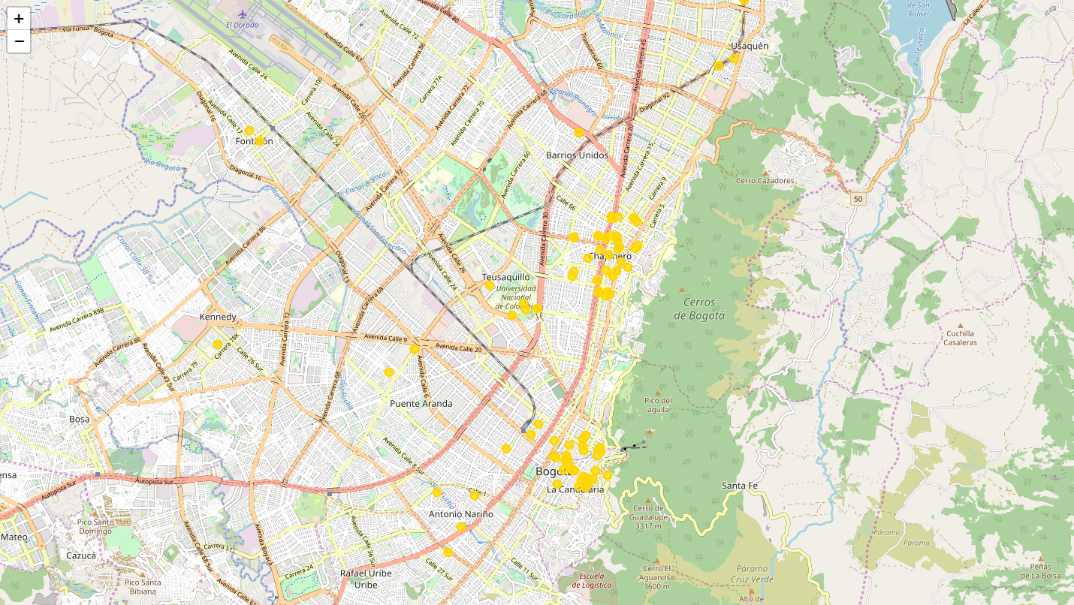

*Offices in Bogotá Localities*

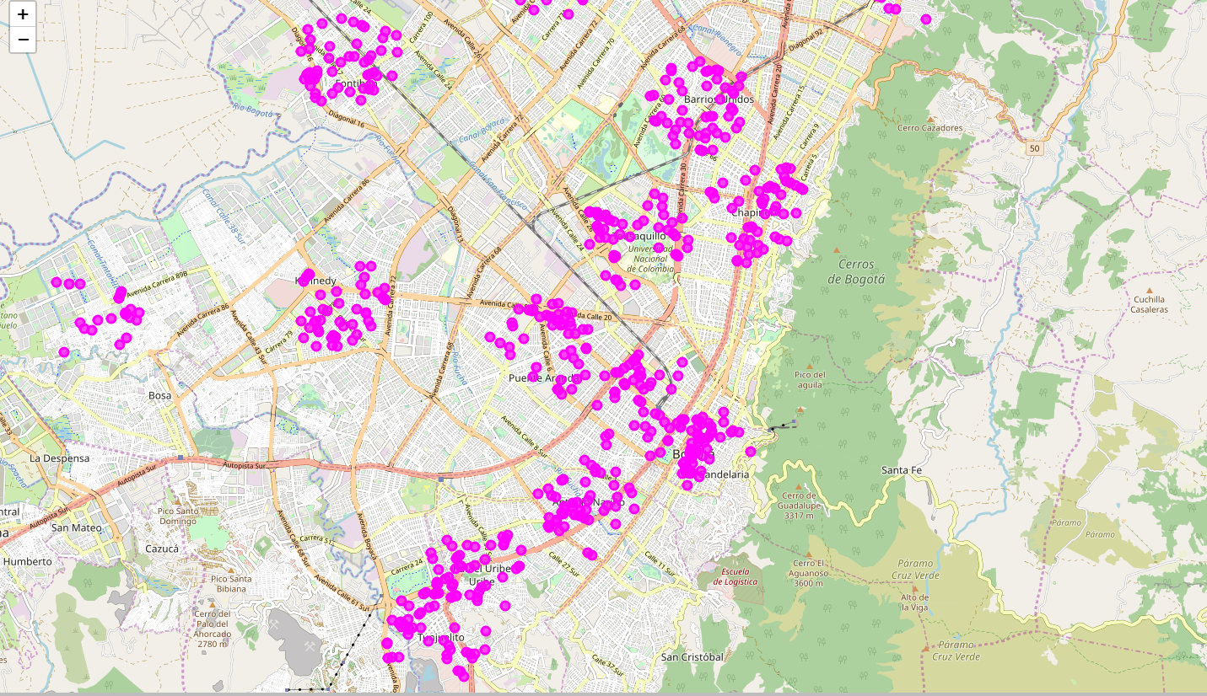

**Results:**

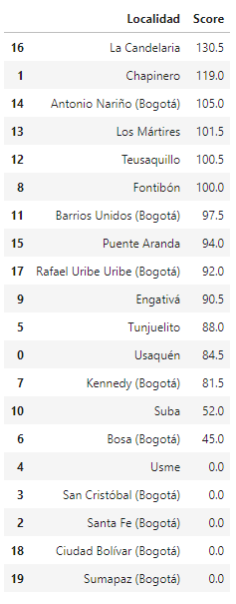

**Conclusion:**

* The Locality with the best score is “La Candelaria” with 130.5, being the best option.
* Follows closely “Chapinero” with 101.

These options maximizes the number of potential customers from offices and universities and at the same time have not too large competence.

***Best Place for the Burger Joint in Bogotá is “La Candelaria”:***

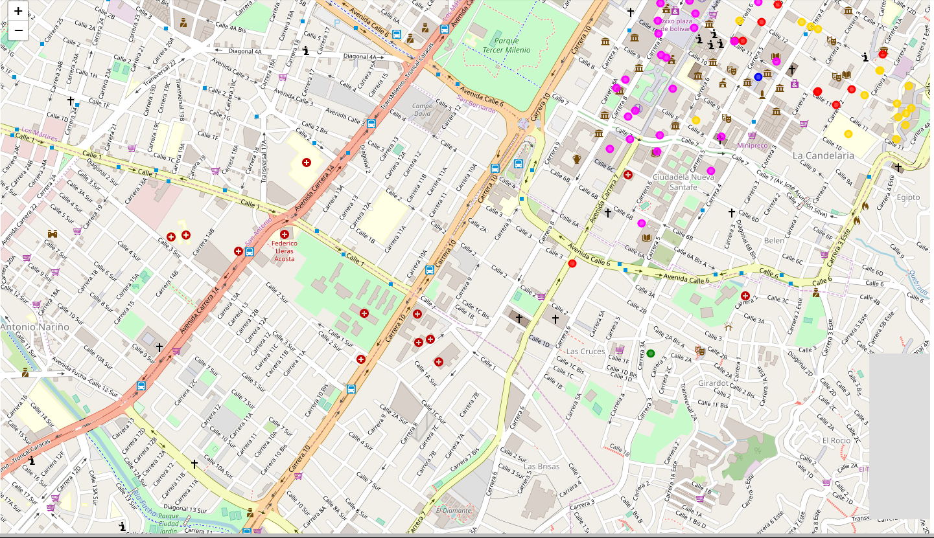

**Recommendation:**

The following analysis can be improved with following extensions:

* Consider more categories. For example like "Night life" which is also a good source for customers. But also like "Restaurants", which even if not burger joints may be some concurrence if too many.
* In the Locality itself, it can also be computed the distance between all the venues in order to find a place with the most number of potential customers.
* Using smaller geographical areas like Neighborhoods could improve the accuracy for the scores.